**MEDALITICS: A Hospital Information System**

**Delegation of Tasks:**

Chad: Literature Review and Report Writing, Raw Data Creation, Presentation Prep, Peer Review

Thomas: ER Diagram without Normalization, Normalization of Tables, Population of Tables with Data

Aditya: Creating Database in Microsoft SQL Server Management studio, Performing all the SQL Command queries

Jose: ER Diagram with and without Normalization, Data Dependency Diagram, Hospital DBMS Research

**Part 1: Introduction and Literature Review**

Due to the COVID-19 events, healthcare topics such as patient rights, vaccination rates, community spread, contact tracing, variant tracking, and herd immunity have all made their way into the world’s regular vocabulary. One of the most important lessons from the pandemic has been the value of having good data to track and treat individuals and to make predictions based on trends. Since the passage of the Health Information Technology for Economic and Clinical Health (HITECH) Act in 2009, nearly every healthcare organization is using a digital patient data management system.1 Performing a quick internet search, hundreds of hospital management services (HMS) can be found. Some systems may try to specialize in one area such as supply chain or billing, while others try to capture everything. One website references 157 different HMS providers that offer appointment scheduling as an option in their software7. The competition space is fierce and gaining market share will be a challenge without differentiation. Figure 1 highlights some of the prevalent features in a modern HMS.

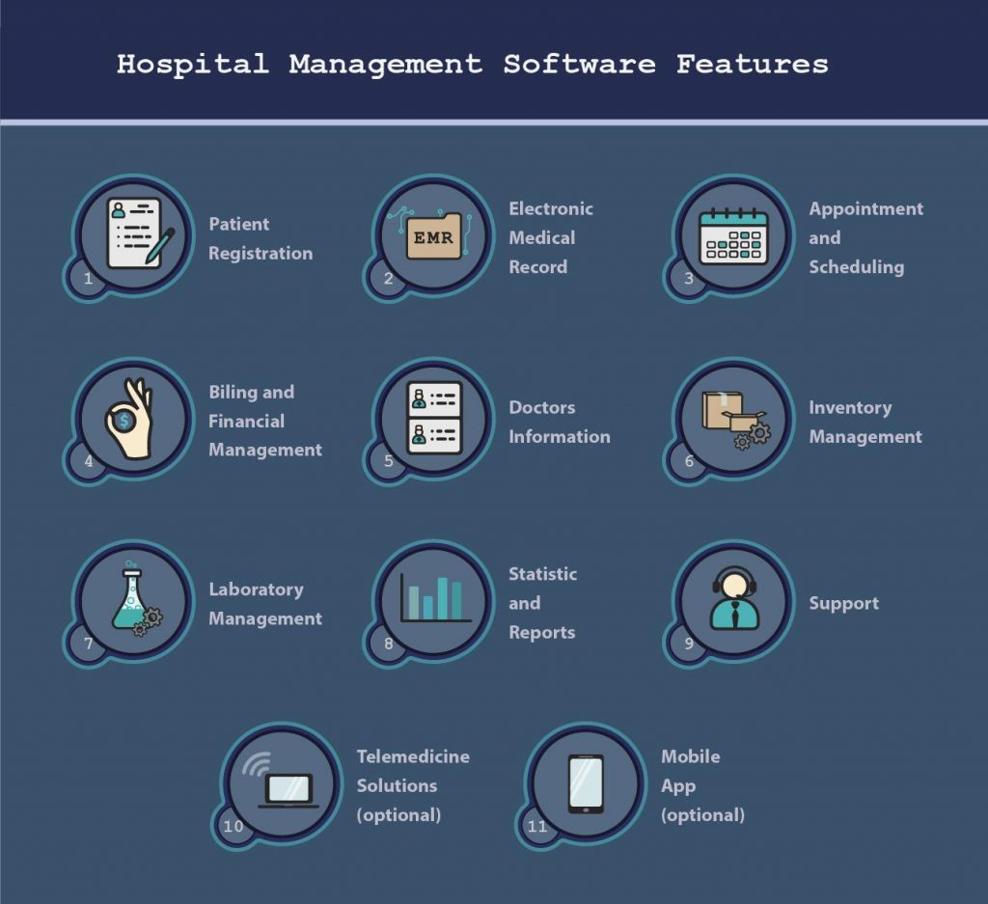

**Figure 1**. The most prevalent must-have features in HMS8

The objective of MEDALITICS is to create a responsive, secure, hospital patient database management system (DBMS) to consolidate patient information into customizable views for providers to make data-driven decisions about patient care and operational effectiveness. Today there are many specialized groups involved in the treatment of a single patient - registration, scheduling, laboratories, supply chain, doctors, staff, facilities, billing, records management, etc. Without a DBMS there is a higher risk of data silos, redundant work, and introduction of errors. Updating records in multiple places or departments takes time away from value-added activities. Additionally, there is no efficient way to analyze patient data or hospital operational data at scale without a DBMS. The goal of MEDALITICS is to reduce redundant work and allow record data to follow patients from one appointment to the next despite visiting different doctors and hospitals. The patient registers once and their entire history follows them and grows with them. No more filling out name, age, height, blood type, employer, and insurance information every visit. More importantly, the providers can access and update an all-inclusive patient record with vitals and past diagnoses in a single place, thus increasing efficiency and effectiveness by minimizing redundancy. MEDALITICS is first focused on the patient and providers and initial plans are to start with a core group of participating hospitals. The solution will be scalable to include additional providers, and more importantly expandable to include features more closely tied to hospital operations (insurance, billing, inventory management, etc).

Some data silos may be required due to provider agreements or law. For instance, HIPAA was implemented in 1996 and placed requirements safeguarding information of patients. HIPAA violations can carry penalties up to $50K and 10 years in prison6. These requirements will have to be understood so the proper privileges can be assigned to various levels of users.

MEDALITICS will ultimately be a consolidated resource for all pertinent patient information such as past and upcoming appointment times, previous medical conditions, recovery times, vital measurements, lab results, etc. It’s understood that providers and departments will need different views and may need a variety of different applications so it is important to remark on this necessity while designing our client-server architecture. Furthermore, factors such as the need for real-time information and low response time may be needed in this environment.

To prioritize the initial features of MEDALITICS, a literature review was performed to identify the current top issues of HMS. As expected, protecting patient information is paramount and was found in every source.

**Table 1**. Top Healthcare DBMS Problems from Literature Review

|  |  |  |  |  |  |
| --- | --- | --- | --- | --- | --- |
|  | **Source References** | | | | |
| **Issue** | **1** | **2** | **3** | **4** | **5** |
| Security and Regulatory Compliance | X | X | X | X | X |
| Predictive Analytics and Workflow Integration | X |  | X |  | X |
| Data Silos |  |  | X | X |  |
| File Updating |  | X |  | X |  |
| Operational Analytics | X |  |  |  | X |
| Staffing |  |  | X |  | X |
| Data Growth |  |  |  | X |  |
| File Retrieval |  | X |  |  |  |
| Mobile Computing | X |  |  |  |  |

MEDALITICS aims to address the top 4 issues. The underlying assumption is that easy access to consistent, real-time information will provide the greatest value to stakeholders. The initial version of MEDALITICS will include information about the Hospital, Doctors, Appointments, Patients, and Medical Records.

The HMS will be implemented in a single hospital, or a small network of hospitals, to test its viability and return on investment. Patients going to the network will benefit from reduced registration times and less redundant paperwork. Adding hospitals and doctors will be relatively trivial, making it very easy to scale MEDALITICS. The last phase will be to allow data analytics teams to look through anonymized patient data for patterns among demographics, regions, and certain diseases to make treatments more effective. Hospitals might be able to identify trends in their operational data to help them analyze staff loads and supply chain needs, thus reducing waste and costs.

**Part 2: ER Diagram without Normalization**

The entity-relationship diagram of the database without normalization is shown in the figure below.

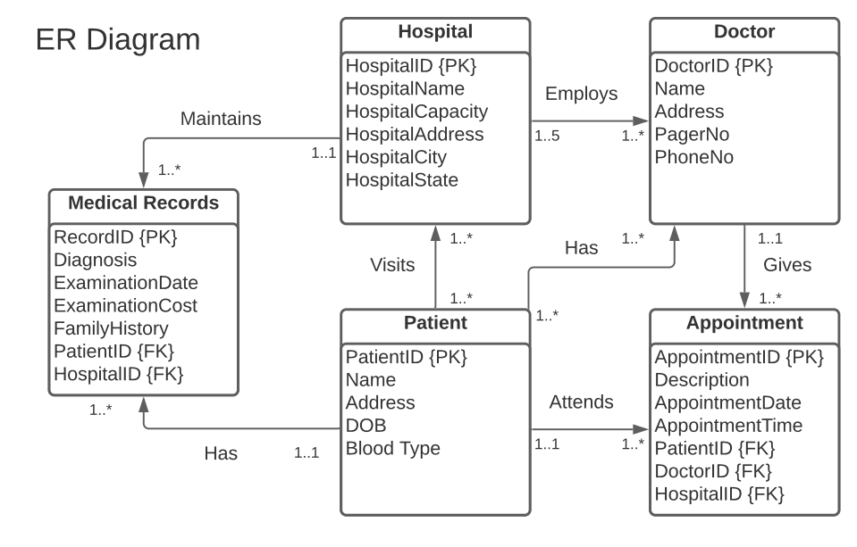

**Figure 2**. ER Diagram for Database

This diagram was created using LucidChart9. In this diagram, the primary keys of a table are followed by a {PK} while the foreign keys are followed by an {FK}. Some important relations to note are that patients can attend more than one hospital and doctors can be employed by multiple hospitals. This will become important when it comes to normalizing these tables.

**Part 3: Normalization**

In the unnormalized form of our initial 5 data tables, there was a lot of repetition with the relationship between doctors, hospitals, and patients since they have one-to-many relationships. Since patients and doctors can both attend and be employed by multiple hospitals, it became necessary to create new tables to show the relationship between the hospital, doctors, and patients. For example, if you looked to find out what hospital the doctor with Id number 4912 worked at then you would have to look on multiple lines, which would be repetitive and could cause issues for the database. These functional dependencies were addressed in the change from first normal form to second normal form, where three new tables were created: Patient-Hospital, Doctor-Hospital, and Patient-Doctor. There were no transitive dependencies so no changes were made in the normalization from the second normal form to the third normal form. The remaining 8 tables that contained the data in the database were now fully normalized.

The 8 normalized tables for the database can be seen below.

**Table 2**. Hospital Table

|  |  |  |  |  |  |
| --- | --- | --- | --- | --- | --- |
| **hID** | **hName** | **hCapacity** | **hAddress** | **hCity** | **hState** |
| 448 | St Mary | 5000 | 2nd St | Birmingham | AL |
| 931 | St Jude | 4500 | 1st St | Anaheim | CA |
| 486 | Providence | 4000 | 4th Ave | White Sands | NM |
| 350 | First Med | 500 | 218 St S | Albany | NY |
| 660 | Second Med | 500 | 480 N Chandler | Atlanta | GA |
| 649 | Urgent Care | 50 | 111 Main St | El Paso | TX |
| 156 | Quick Med | 20 | 29 West Blvd | Norman | OK |
| 531 | TriCare | 100 | 0 Alamo Way | Dallas | TX |
| 596 | TriCare South | 150 | 323 Park Pl | Houston | TX |
| 798 | Northwest Med | 900 | 512 Glacier Rd | Spokane | WA |

**Table 3**. Doctor Table

|  |  |  |  |  |
| --- | --- | --- | --- | --- |
| **dID** | **dName** | **dAddress** | **pagerNo** | **phoneNo** |
| 4912 | Novak | 9050 Westminster St. | (404) 408-9963 | (866) 779-7571 |
| 2317 | Bowers | 9398 Main Dr. | (859) 709-6828 | (845) 533-8450 |
| 3507 | Christian | 513 Cedar Swamp St. | (642) 211-1114 | (663) 438-5332 |
| 5530 | Shepherd | 77 North Briarwood Ave. | (493) 739-0738 | (573) 342-2112 |
| 1543 | Dunlap | 186 Crescent Drive | (622) 842-6754 | (593) 215-6192 |
| 5112 | Oneill | 7564 Sutor Street | (696) 519-7680 | (714) 575-1641 |
| 3381 | Mueller | 7640 Trout Dr. | (223) 529-6831 | (992) 979-9452 |
| 9351 | Mcintyre | 85 Queen St. | (478) 715-6391 | (555) 558-6488 |
| 6269 | Johnson | 7294 King St. | (334) 470-0929 | (485) 410-2836 |
| 9035 | Gregory | 90 Marsh Rd. | (731) 345-6827 | (823) 494-0243 |
| 5110 | Goodwin | 168 Brandywine St. | (636) 342-4676 | (571) 793-8499 |
| 3749 | Ryan | 338 Trusel Rd. | (573) 458-4699 | (374) 315-7029 |

**Table 4**. Doctor-Hospital Relation Table

|  |  |
| --- | --- |
| **dID** | **hID** |
| 4912 | 448 |
| 2317 | 486 |
| 3507 | 660 |
| 5530 | 448 |
| 1543 | 931 |
| 5112 | 486 |
| 3381 | 350 |
| 9351 | 660 |
| 6269 | 649 |
| 9035 | 156 |
| 2317 | 531 |
| 3749 | 596 |
| 4912 | 798 |
| 2317 | 448 |
| 3507 | 931 |
| 5530 | 486 |
| 1543 | 350 |
| 3381 | 660 |
| 9351 | 531 |
| 3381 | 596 |
| 6269 | 798 |
| 9035 | 649 |

**Table 5**. Records Table

|  |  |  |  |  |  |  |
| --- | --- | --- | --- | --- | --- | --- |
| **rID** | **diagnosis** | **examDate** | **examCost** | **famHistory** | **pID** | **hID** |
| 21985 | Nondisplaced fracture of neck of other metacarpal bone | 10/13/2020 | $ 4,277.45 | Osteoporosis | 249G | 596 |
| 21986 | Placenta previa with hemorrhage, second trimester | 10/16/2020 | $ 1,023.34 | None | 689N | 798 |
| 21987 | Laceration with foreign body of right ring finger with damage to nail | 10/21/2020 | $ 1,197.89 | None | 483J | 448 |
| 21988 | Other spotted fevers | 10/22/2020 | $ 6,719.26 | Cancer | 922S | 931 |
| 21989 | Altered mental status, unspecified | 10/29/2020 | $ 4,300.41 | Depression | 836B | 486 |
| 21990 | Traumatic rupture of unspecified ligament of right little finger at metacarpophalangeal and interphalangeal joint | 11/2/2020 | $ 4,584.85 | Diabetes | 412T | 350 |
| 21991 | Bus occupant (driver) (passenger) injured in other specified transport accidents | 11/3/2020 | $ 8,655.09 | None | 719C | 660 |
| 21992 | Unspecified occupant of heavy transport vehicle injured in collision with heavy transport vehicle or bus in nontraffic accident | 11/24/2020 | $ 6,502.90 | None | 337I | 531 |
| 21993 | Anaplastic large cell lymphoma, ALK-negative, unspecified site | 12/1/2020 | $ 8,786.99 | Cancer | 188E | 596 |
| 21994 | Military operations involving unarmed hand to hand combat, civilian | 12/7/2020 | $ 6,102.97 | None | 603L | 448 |
| 21995 | Subacute osteomyelitis, right tibia, and fibula | 12/8/2020 | $ 9,802.34 | Osteoporosis | 422M | 486 |
| 21996 | Laceration without foreign body of back wall of thorax without penetration into thoracic cavity | 12/9/2020 | $ 3,611.45 | Hypertension | 60H | 660 |
| 21997 | Salter-Harris Type III physeal fracture of upper end of humerus | 12/14/2020 | $ 2,186.29 | Stroke | 938F | 448 |
| 21998 | Vesical fistula, not elsewhere classified | 12/16/2020 | $ 2,487.38 | None | 430A | 931 |
| 21999 | Angiodysplasia of colon | 12/17/2020 | $ 1,079.76 | Diabetes | 680V | 486 |
| 22000 | Torus fracture of upper end of humerus | 12/21/2020 | $ 9,466.32 | Osteoporosis | 899O | 350 |
| 22001 | Other specified injury of other blood vessels at lower leg level, unspecified leg | 12/22/2020 | $ 2,642.81 | Hypertension | 35U | 660 |
| 22002 | Resistance to unspecified beta-lactam antibiotics | 12/24/2020 | $ 8,935.57 | Hypertension | 888P | 649 |
| 22003 | Laceration of other muscles, fascia and tendons at shoulder and upper arm level, left arm | 12/28/2020 | $ 8,703.15 | None | 220D | 156 |
| 22004 | Placenta previa with hemorrhage, second trimester | 12/30/2020 | $ 8,186.49 | None | 621K | 531 |

**Table 6**. Patient Table

|  |  |  |  |  |
| --- | --- | --- | --- | --- |
| **pID** | **pName** | **pAddress** | **pDOB** | **pBloodType** |
| 603L | Jimenez | 989 Elmwood St. | 4/5/1998 | A- |
| 422M | Giles | 929 Creekside St. | 10/9/1980 | O+ |
| 60H | Eaton | 7781 Gregory Ave. | 8/23/1985 | B+ |
| 938F | Yates | 9350 Van Dyke St. | 12/28/1995 | A+ |
| 430A | Mooney | 37 Pawnee Street | 4/28/2000 | B- |
| 680V | Gay | 163 E. Plymouth Lane | 10/24/1984 | O- |
| 899O | Harmon | 11 Randall Mill St. | 3/11/1994 | AB+ |
| 35U | Mccullough | 8016 W. Greenrose Ave. | 4/27/1973 | AB- |
| 888P | Miller | 542 Armstrong St. | 3/29/1984 | A- |
| 220D | Yang | 8348 Beechwood Ave. | 1/1/1979 | O+ |
| 621K | Case | 72 Purple Finch St. | 5/31/1971 | B+ |
| 249G | Baxter | 6 St Margarets Street | 5/8/1995 | A+ |
| 689N | Heath | 76 North Pin Oak St. | 3/14/1975 | B- |
| 483J | Buchanan | 41 Queen St. | 7/27/1980 | O- |
| 922S | Peck | 413 Clay Lane | 1/6/1975 | AB+ |
| 836B | Barrett | 66 University Street | 11/7/1990 | AB- |
| 412T | Burgess | 80 King Court | 6/6/1994 | A- |
| 719C | Mccoy | 80 SW. Bay St. | 11/24/1991 | O+ |
| 337I | Rodriguez | 611 Manhattan Street | 12/25/2000 | B+ |
| 188E | Campbell | 9921 South Sunnyslope Ave. | 8/28/1999 | A+ |

**Table 7**. Patient-Hospital Relation Table

|  |  |
| --- | --- |
| **pID** | **hID** |
| 603L | 448 |
| 422M | 486 |
| 60H | 660 |
| 938F | 448 |
| 430A | 931 |
| 680V | 486 |
| 899O | 350 |
| 35U | 660 |
| 888P | 649 |
| 220D | 156 |
| 621K | 531 |
| 249G | 596 |
| 689N | 798 |
| 483J | 448 |
| 922S | 931 |
| 836B | 486 |
| 412T | 350 |
| 719C | 660 |
| 337I | 531 |
| 188E | 596 |
| 422M | 798 |
| 680V | 649 |
| 220D | 156 |
| 922S | 531 |
| 337I | 596 |
| 483J | 798 |

**Table 8**. Appointment Table

|  |  |  |  |  |  |  |
| --- | --- | --- | --- | --- | --- | --- |
| **aID** | **aDescription** | **aDate** | **aTime** | **pID** | **dID** | **hID** |
| 2561 | Physical | 1/26/2022 | 9:25:00 AM | 719C | 3381 | 448 |
| 2562 | Physical | 12/13/2021 | 1:00:00 PM | 337I | 9351 | 486 |
| 2563 | Surgery | 12/14/2021 | 11:55:00 AM | 188E | 3381 | 660 |
| 2564 | Routine | 1/27/2022 | 4:55:00 PM | 422M | 6269 | 448 |
| 2565 | Physical | 1/12/2022 | 11:20:00 AM | 680V | 9035 | 931 |
| 2566 | Routine | 1/25/2022 | 1:45:00 PM | 220D | 5110 | 486 |
| 2567 | Lab work | 1/21/2022 | 9:10:00 AM | 922S | 5110 | 350 |
| 2568 | Lab work | 1/13/2022 | 11:15:00 AM | 337I | 4912 | 660 |
| 2569 | Surgery | 1/6/2022 | 2:50:00 PM | 483J | 5112 | 649 |
| 2570 | Routine | 1/14/2022 | 10:40:00 AM | 422M | 2317 | 156 |
| 2571 | Routine | 1/3/2022 | 1:30:00 PM | 60H | 3507 | 531 |
| 2572 | Physical | 1/11/2022 | 1:55:00 PM | 938F | 5530 | 596 |
| 2573 | x-Ray | 12/22/2021 | 2:15:00 PM | 430A | 1543 | 798 |
| 2574 | Routine | 1/20/2022 | 3:40:00 PM | 680V | 5112 | 448 |
| 2575 | x-Ray | 12/21/2021 | 9:50:00 AM | 899O | 3381 | 931 |
| 2576 | Lab work | 1/5/2022 | 5:00:00 PM | 35U | 9351 | 486 |
| 2577 | Surgery | 12/15/2021 | 9:15:00 AM | 888P | 6269 | 350 |
| 2578 | x-Ray | 12/31/2021 | 4:30:00 PM | 220D | 9035 | 660 |
| 2579 | Lab work | 1/7/2022 | 4:50:00 PM | 621K | 2317 | 531 |
| 2580 | x-Ray | 12/24/2021 | 12:40:00 PM | 249G | 3749 | 596 |

**Table 9**. Patient-Doctor Relation Table

|  |  |
| --- | --- |
| **pID** | **dID** |
| 603L | 4912 |
| 422M | 2317 |
| 60H | 3507 |
| 938F | 5530 |
| 430A | 1543 |
| 680V | 5112 |
| 899O | 3381 |
| 35U | 9351 |
| 888P | 6269 |
| 220D | 9035 |
| 621K | 2317 |
| 249G | 3749 |
| 689N | 4912 |
| 483J | 2317 |
| 922S | 3507 |
| 836B | 5530 |
| 412T | 1543 |
| 719C | 3381 |
| 337I | 9351 |
| 188E | 3381 |
| 422M | 6269 |
| 680V | 9035 |
| 220D | 5110 |
| 922S | 5110 |
| 337I | 4912 |
| 483J | 5112 |

Dependency preservation property enables us to enforce a constraint on the original relation by enforcing some constraint on each of the smaller relations. Identifying all functional dependencies between a set of attributes is relatively simple if the meaning of each attribute and the relationships between the attributes are well understood. The following dependencies are set to be provided by the enterprise in the form of discussions with users and/or documentation such as the doctors’ requirements specification.

|  |  |  |
| --- | --- | --- |
| **Determinant** | **→** | **Functional Dependency** |
| HospitalID | → | (Hospital) Name, Capacity, Address, City, State |
| DoctorID | → | (Doctor) Name, Address, PagerNo, PhoneNo |
| AppointmentID | → | Description, ApptDate, ApptTime, PatientID, DoctorID, HospitalID |
| PatientID | → | (Patient) Name, Address, DOB, Blood Type |
| RecordID | → | Diagnosis, ExamDate, ExamCost, FamilyHistory, PatientID, HospitalID |

SQL

**REFERENCES**

1. “The Top Six Challenges of Healthcare Data Management.” Ingrammicro.Com, <https://imaginenext.ingrammicro.com/data-center/the-top-six-challenges-of-healthcare-data-management>. Accessed 20 Oct. 2021.
2. Amaechi James C., Agbasonu Valerian C., and Nwawudu Sixtus E. “Design and Implementation of a Hospital Database Management System (HDMS) for Medical Doctors.” International Journal of Computer Theory and Engineering, vol. 10, no. 1, Feb. 2018, doi:10.7763.
3. Bresnick, Jennifer. “How Big Data Analytics Underpins Every Healthcare Trend.” Healthitanalytics.com, 31 July 2017, <https://healthitanalytics.com/news/how-big-data-analytics-underpins-every-healthcare-trend>.
4. MediQuant. “Health Care Data Management: 5 Ways to Overcome Its Major Challenges.” Mediquant.Com, 22 Jan. 2021, <https://www.mediquant.com/health-care-data-management-5-ways-to-overcome-its-major-challenges/>.
5. “Data Management in Healthcare: Challenges and Opportunities.” Clicdata.Com, 3 July 2019, <https://www.clicdata.com/blog/data-management-in-healthcare-challenges-and-opportunities/>.
6. HIPAA Journal. “What Are the Penalties for HIPAA Violations?” Hipaajournal.Com, 15 Jan. 2021, https://www.hipaajournal.com/what-are-the-penalties-for-hipaa-violations-7096/.
7. “Best Hospital Management Software.” Capterra.com, <https://www.capterra.com/hospital-management-software/>
8. Bogdan, Mykhailo. “How to Develop a Hospital Management System.” Kindgeek.Com, 12 Dec. 2019, <https://kindgeek.com/blog/post/how-to-develop-a-hospital-management-system>.
9. LucidChart. <https://lucidchart.com/>

The Select statement is used to select data from a database.

Insert into Statement:-The insert into statement is used to insert a new record into the table.

Delete Statement:- This statement is used when we need to delete a record from any table.

Update Statement: This statement is used to update any existing record where changes are needed to be done

Count Statement: This statement is used to count records in a table

Full Join Statement: This statement returns all the record when there is a match in left or right table records.

Left join statement: The Left join keyword returns all records from the left table and the matching records from the right table. The result is null records from the right side, if there is no match.

Right Join Statement: The Right join keyword returns all records from the right table and the matching records from the left table. The result is Null records from the left side, if there is no match.  
SQL Wildcard(Like Operator): We are finding for Patient Address which contains ‘ee’